UEE410 Submitted by:

Abhiveer Pathania

102354005

3D12

Assignment 4

// Question 1: Write a menu driven program with 4 options (Push, Pop, Display, and Exit) to demonstrate the working of stacks using arrays.

#include <stdio.h>

#include <stdlib.h>

#define MAX_SIZE 100

int stack[MAX_SIZE];

int top = -1;

void push(int value) {

    if (top >= MAX_SIZE - 1) {

        printf("Stack Overflow! Cannot push more elements.\n");

    } else {

        stack[++top] = value;

        printf("Pushed %d to the stack.\n", value);

    }

}

void pop() {

    if (top < 0) {

        printf("Stack Underflow! Stack is empty.\n");

    } else {

        printf("Popped %d from the stack.\n", stack[top--]);

    }

}

void display() {

    if (top < 0) {

        printf("Stack is empty.\n");

    } else {

        printf("Stack elements: ");

        for (int i = top; i >= 0; i--) {

            printf("%d ", stack[i]);

        }

        printf("\n");

    }

}

int main() {

    int choice, value;

    do {

        printf("\nStack Operations Menu:\n");

        printf("1. Push\n");

        printf("2. Pop\n");

        printf("3. Display\n");

        printf("4. Exit\n");

        printf("Enter your choice: ");

        scanf("%d", &choice);

        switch (choice) {

            case 1:

                printf("Enter value to push: ");

                scanf("%d", &value);

                push(value);

                break;

            case 2:

                pop();

                break;

            case 3:

                display();

                break;

            case 4:

                printf("Exiting program.\n");

                break;

            default:

                printf("Invalid choice. Please try again.\n");

        }

    } while (choice != 4);

    return 0;

}

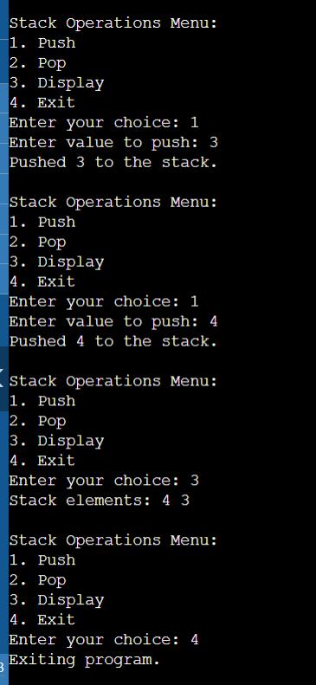

// Question 2: Write a menu driven program with 4 options (Push, Pop, Display, and Exit) to demonstrate the working of stacks using linked-list.

#include <stdio.h>

#include <stdlib.h>

struct Node {

    int data;

    struct Node *next;

};

struct Node *top_ll = NULL;

void push_ll(int value) {

    struct Node *newNode = (struct Node *)malloc(sizeof(struct Node));

    if (newNode == NULL) {

        printf("Memory allocation failed.\n");

        return;

    }

    newNode->data = value;

    newNode->next = top_ll;

    top_ll = newNode;

    printf("Pushed %d to the stack.\n", value);

}

void pop_ll() {

    if (top_ll == NULL) {

        printf("Stack Underflow! Stack is empty.\n");

        return;

    }

    struct Node *temp = top_ll;

    top_ll = top_ll->next;

    printf("Popped %d from the stack.\n", temp->data);

    free(temp);

}

void display_ll() {

    if (top_ll == NULL) {

        printf("Stack is empty.\n");

        return;

    }

    struct Node *current = top_ll;

    printf("Stack elements: ");

    while (current != NULL) {

        printf("%d ", current->data);

        current = current->next;

    }

    printf("\n");

}

int main() {

    int choice, value;

    do {

        printf("\nLinked List Stack Operations Menu:\n");

        printf("1. Push\n");

        printf("2. Pop\n");

        printf("3. Display\n");

        printf("4. Exit\n");

        printf("Enter your choice: ");

        scanf("%d", &choice);

        switch (choice) {

            case 1:

                printf("Enter value to push: ");

                scanf("%d", &value);

                push_ll(value);

                break;

            case 2:

                pop_ll();

                break;

            case 3:

                display_ll();

                break;

            case 4:

                printf("Exiting program.\n");

                break;

            default:

                printf("Invalid choice. Please try again.\n");

        }

    } while (choice != 4);

    return 0;

}

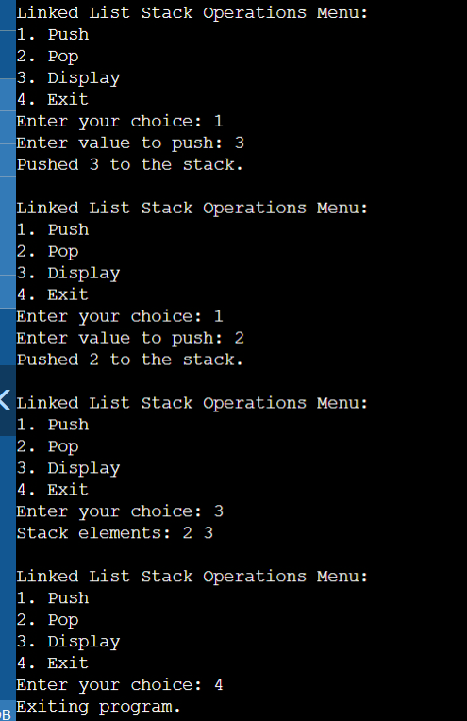

// Question 3: Write a program to convert infix expression into postfix expression using stack.

#include <stdio.h>

#include <stdlib.h>

#include <string.h>

#include <ctype.h>

#define MAX_SIZE 100

char stack_infix[MAX_SIZE];

int top_infix = -1;

void push_infix(char op) {

    if (top_infix >= MAX_SIZE - 1) {

        printf("Stack Overflow\n");

        return;

    }

    stack_infix[++top_infix] = op;

}

char pop_infix() {

    if (top_infix < 0) {

        return '\0';

    }

    return stack_infix[top_infix--];

}

int precedence(char op) {

    if (op == '+' || op == '-') {

        return 1;

    }

    if (op == '*' || op == '/') {

        return 2;

    }

    return 0;

}

void infixToPostfix(char* infix, char* postfix) {

    int i, j;

    char op;

    for (i = 0, j = 0; infix[i] != '\0'; i++) {

        if (isalnum(infix[i])) {

            postfix[j++] = infix[i];

        } else if (infix[i] == '(') {

            push_infix(infix[i]);

        } else if (infix[i] == ')') {

            while (top_infix != -1 && stack_infix[top_infix] != '(') {

                postfix[j++] = pop_infix();

            }

            if (top_infix != -1 && stack_infix[top_infix] != '(') {

                printf("Invalid Expression\n");

                return;

            } else {

                pop_infix();

            }

        } else {

            while (top_infix != -1 && precedence(stack_infix[top_infix]) >= precedence(infix[i])) {

                postfix[j++] = pop_infix();

            }

            push_infix(infix[i]);

        }

    }

    while (top_infix != -1) {

        if (stack_infix[top_infix] == '(') {

            printf("Invalid Expression\n");

            return;

        }

        postfix[j++] = pop_infix();

    }

    postfix[j] = '\0';

}

int main() {

    char infix[MAX_SIZE];

    char postfix[MAX_SIZE];

    printf("Enter an infix expression: ");

    scanf("%s", infix);

    infixToPostfix(infix, postfix);

    printf("The postfix expression is: %s\n", postfix);

    return 0;

}

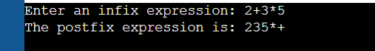

// Question 4: Write a program to convert infix expression into prefix expression using stack.

#include <stdio.h>

#include <stdlib.h>

#include <string.h>

#include <ctype.h>

#define MAX_SIZE 100

char stack_prefix[MAX_SIZE];

int top_prefix = -1;

void push_prefix(char op) {

    if (top_prefix >= MAX_SIZE - 1) {

        printf("Stack Overflow\n");

        return;

    }

    stack_prefix[++top_prefix] = op;

}

char pop_prefix() {

    if (top_prefix < 0) {

        return '\0';

    }

    return stack_prefix[top_prefix--];

}

void reverseString(char* str) {

    int len = strlen(str);

    int i, j;

    char temp;

    for (i = 0, j = len - 1; i < j; i++, j--) {

        temp = str[i];

        str[i] = str[j];

        str[j] = temp;

    }

}

int precedence_prefix(char op) {

    if (op == '+' || op == '-') {

        return 1;

    }

    if (op == '*' || op == '/') {

        return 2;

    }

    return 0;

}

void infixToPrefix(char* infix, char* prefix) {

    int i, j;

    char op;

    reverseString(infix);

    for (i = 0, j = 0; infix[i] != '\0'; i++) {

        if (infix[i] == '(') {

            infix[i] = ')';

        } else if (infix[i] == ')') {

            infix[i] = '(';

        }

    }

    for (i = 0; infix[i] != '\0'; i++) {

        if (isalnum(infix[i])) {

            prefix[j++] = infix[i];

        } else if (infix[i] == '(') {

            push_prefix(infix[i]);

        } else if (infix[i] == ')') {

            while (top_prefix != -1 && stack_prefix[top_prefix] != '(') {

                prefix[j++] = pop_prefix();

            }

            if (top_prefix != -1 && stack_prefix[top_prefix] != '(') {

                printf("Invalid Expression\n");

                return;

            } else {

                pop_prefix();

            }

        } else {

            while (top_prefix != -1 && precedence_prefix(stack_prefix[top_prefix]) >= precedence_prefix(infix[i])) {

                prefix[j++] = pop_prefix();

            }

            push_prefix(infix[i]);

        }

    }

    while (top_prefix != -1) {

        if (stack_prefix[top_prefix] == '(') {

            printf("Invalid Expression\n");

            return;

        }

        prefix[j++] = pop_prefix();

    }

    prefix[j] = '\0';

    reverseString(prefix);

}

int main() {

    char infix[MAX_SIZE];

    char prefix[MAX_SIZE];

    printf("Enter an infix expression: ");

    scanf("%s", infix);

    infixToPrefix(infix, prefix);

    printf("The prefix expression is: %s\n", prefix);

    return 0;

}



// Question 5: Write a program to evaluate a postfix expression using stack.

#include <stdio.h>

#include <stdlib.h>

#include <ctype.h>

#include <string.h>

#define MAX_SIZE 100

int stack_eval[MAX_SIZE];

int top_eval = -1;

void push_eval(int value) {

    if (top_eval >= MAX_SIZE - 1) {

        printf("Stack Overflow\n");

        return;

    }

    stack_eval[++top_eval] = value;

}

int pop_eval() {

    if (top_eval < 0) {

        return -1; // Indicates error

    }

    return stack_eval[top_eval--];

}

int evaluatePostfix(char* postfix) {

    int i;

    for (i = 0; postfix[i] != '\0'; i++) {

        if (isdigit(postfix[i])) {

            push_eval(postfix[i] - '0');

        } else {

            int op2 = pop_eval();

            int op1 = pop_eval();

            switch (postfix[i]) {

                case '+': push_eval(op1 + op2); break;

                case '-': push_eval(op1 - op2); break;

                case '*': push_eval(op1 * op2); break;

                case '/': push_eval(op1 / op2); break;

                default: printf("Invalid operator\n"); return -1;

            }

        }

    }

    return pop_eval();

}

int main() {

    char postfix[MAX_SIZE];

    printf("Enter a postfix expression (single-digit operands): ");

    scanf("%s", postfix);

    int result = evaluatePostfix(postfix);

    if (result != -1) {

        printf("Result of the postfix expression: %d\n", result);

    }

    return 0;

}

